

Colegio Tecnológico Pulmahue

Worksheet 2nd grade of high school

NOMBRE_____________________________FECHA______

El objetivo de esta actividad es que el estudiante conozca vocabulario sobre maneras de comunicarse y pueda identificarlo mediante imágenes.
O.A: Reconocer vocabulario sobre formas de comunicarse

HANDOUT – MEANS OF COMMUNICATION
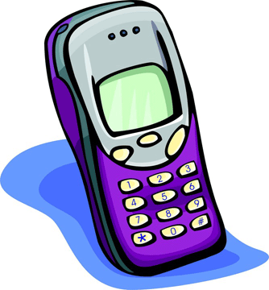
CELLPHONE
It is for sending message and calling.
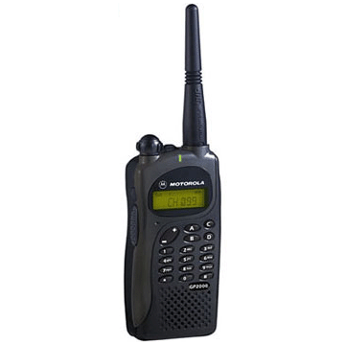
HANDY TALKY
It is for giving information.

FAX MACHINE
It is for sending fax.

COMPUTER
It is for typing.

NEWSPAPER
It is for reading news.
It is published daily.
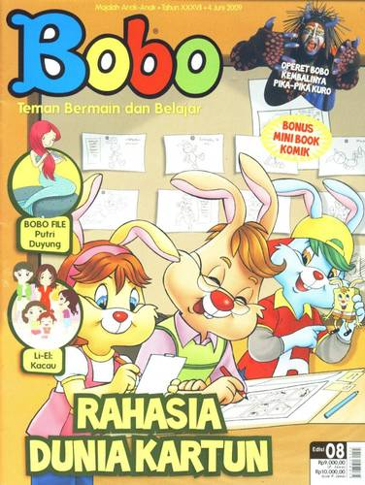
MAGAZINE
It is for reading news.


LETTER
It is for sending information by post.

NOTEBOOK
It is for typing.
It is portable.

INTERNET
It is for searching information and news.
It is for sending e-mail.

RADIO
It is for listening news.

TELEGRAM
It is for sending message by post.
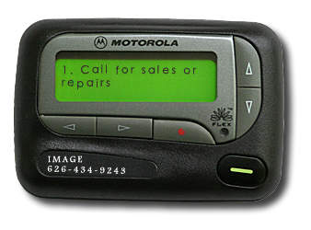
PAGER
It is for sending message.

TELEVISION
It is for watching audiovisual news.

TELEPHONE
It is for calling.

COMPLETE THE DIALOGUES WITH THE WORDS IN THE BOX!
television computer magazine radio cellphone
newspaper telephone letter fax machine notebook
Dina : What is it?
Voni : It is telegram
1.
Lisa : What is it?
Adi : It is ………………
2.
John : What is it?
Tika : It is ………………
3.
Ica : What is it?
Eni : It is ………………..
4.
Nina : What is it?
Joko : It is ……………..
5.
Ana : What is it?
Ani : It is ………………
6.
Ria : What is it?
Edo : It is ……………….
7.
Miki : What is it?
Mini : It is ……………..
8. .
Feli : What is it?
Isal : It is ……………….
9.
Yuli : What is it?
Nani : It is …………….
10.
Billy : What is it?
Nunu : It is …………….

